**Title: Deferred Shading**

**1.0 Purpose**

Implement deferred shading.

**2.0 Method/Results**

Firtly, within the given fragment shader I worked on the given to-do list, I was to amend the code to do the following;

Retrieve position, normal, and colour information from textures each as a vec 3, then call diffuseModel() to determine FragColour and use ambient and diffuse lighting, I have done all of this below;

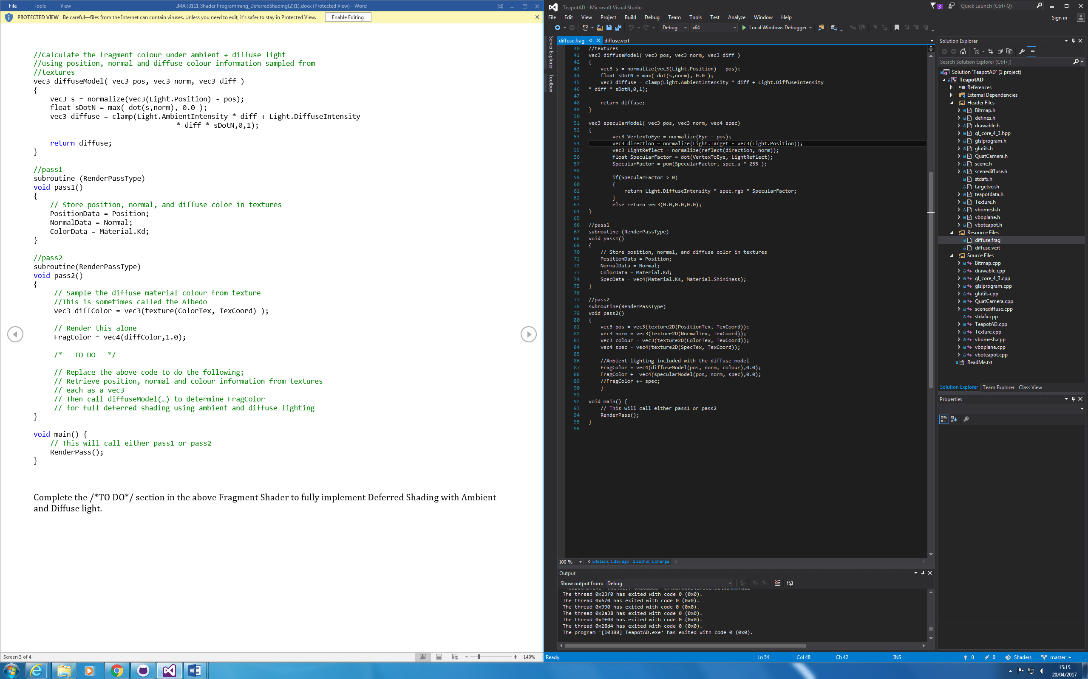

I then had to add another texture for Specular lighting;

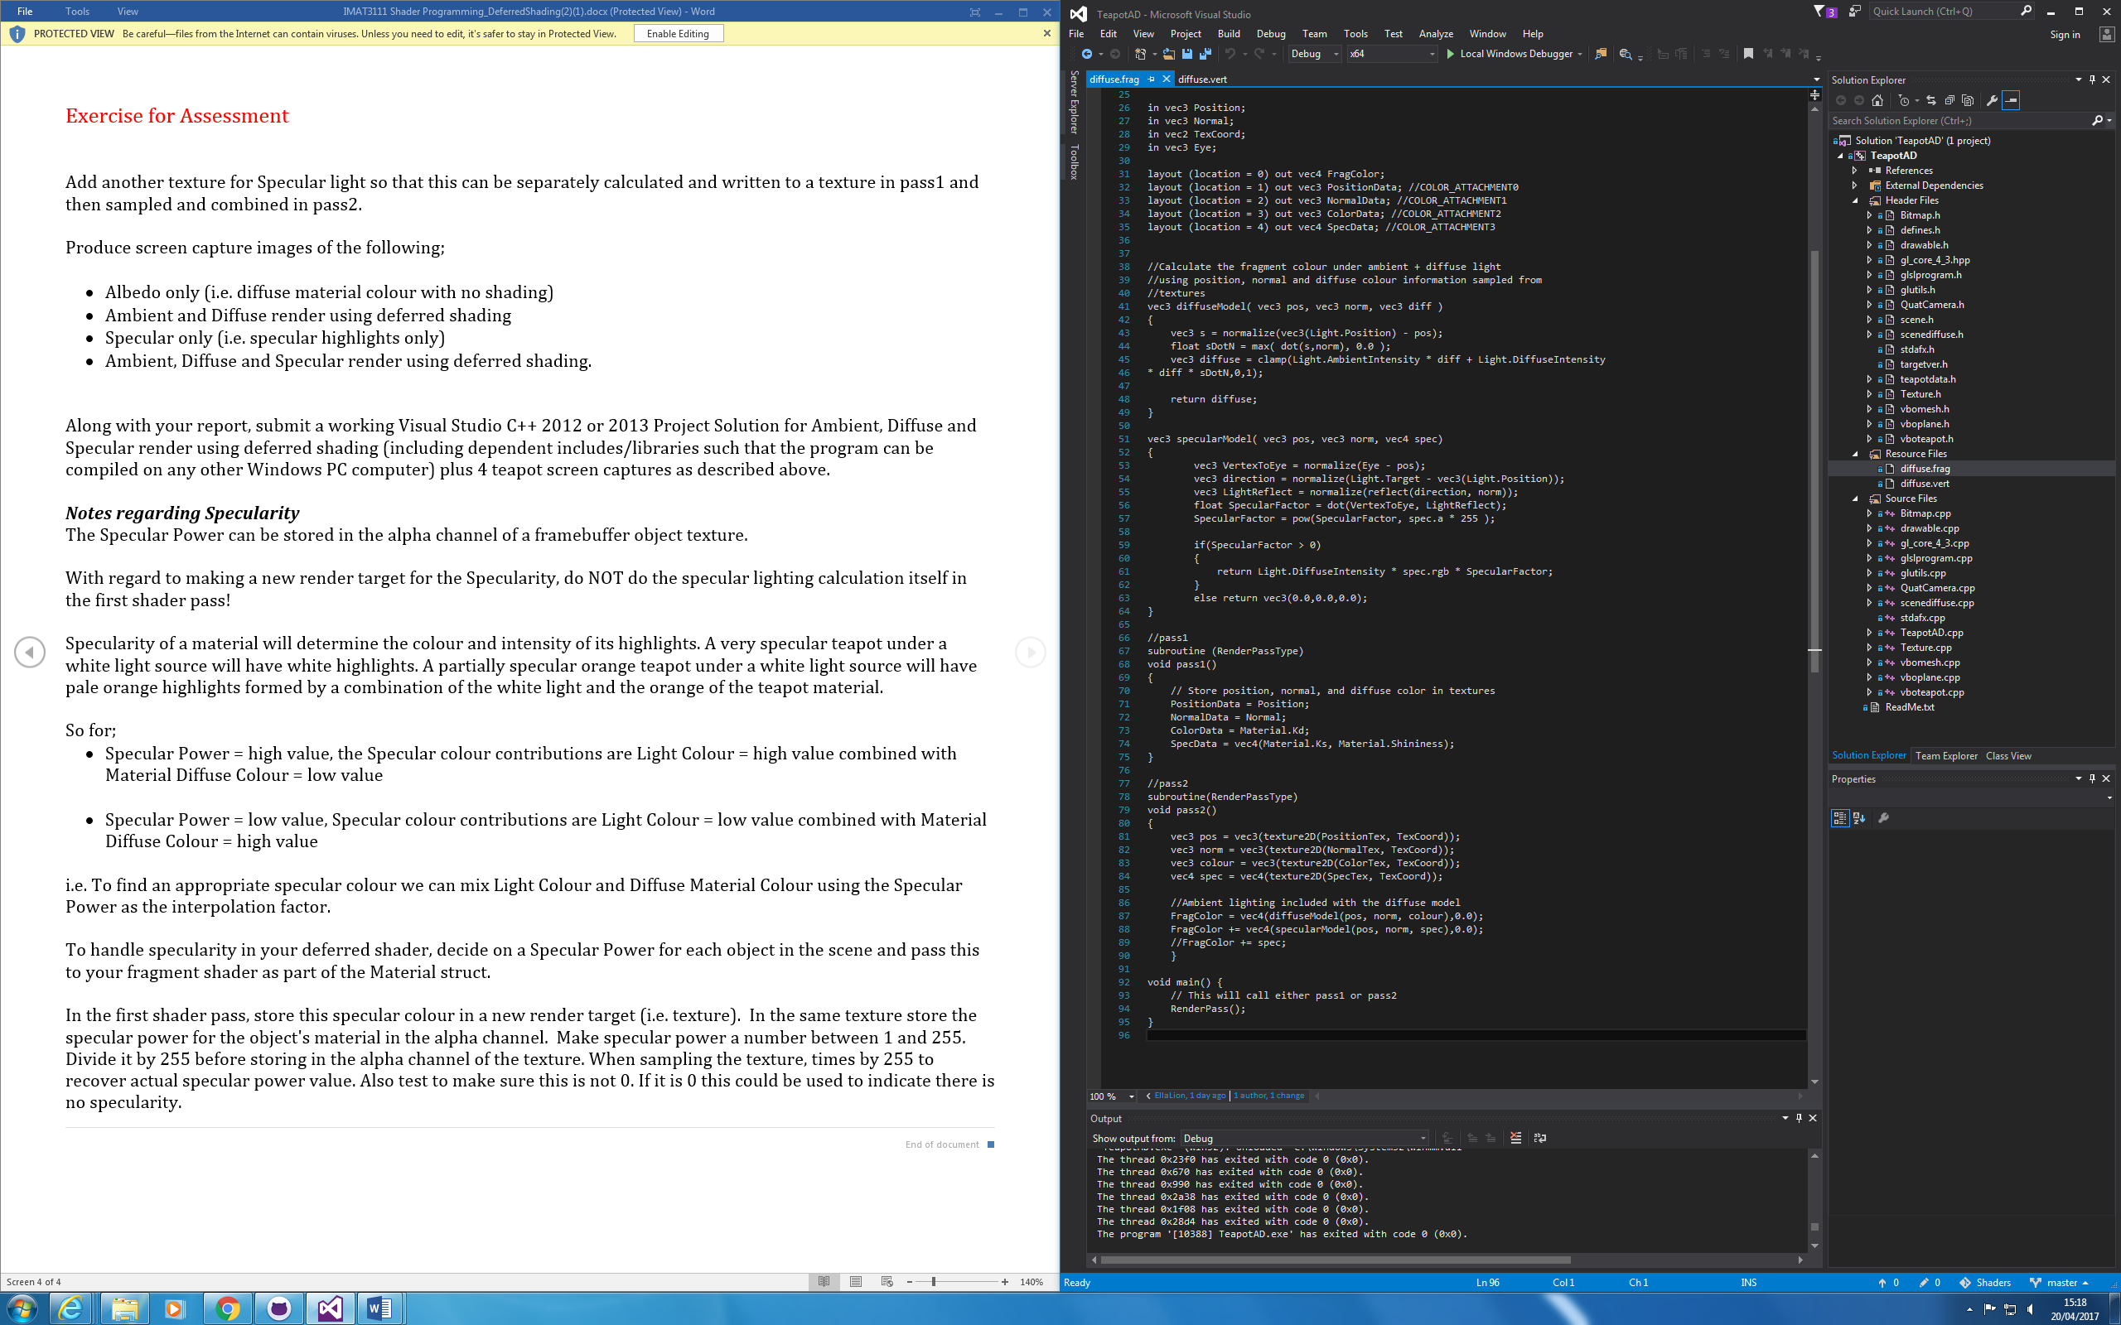

**3.0 Comments/Conclusion**

Ambient Only;

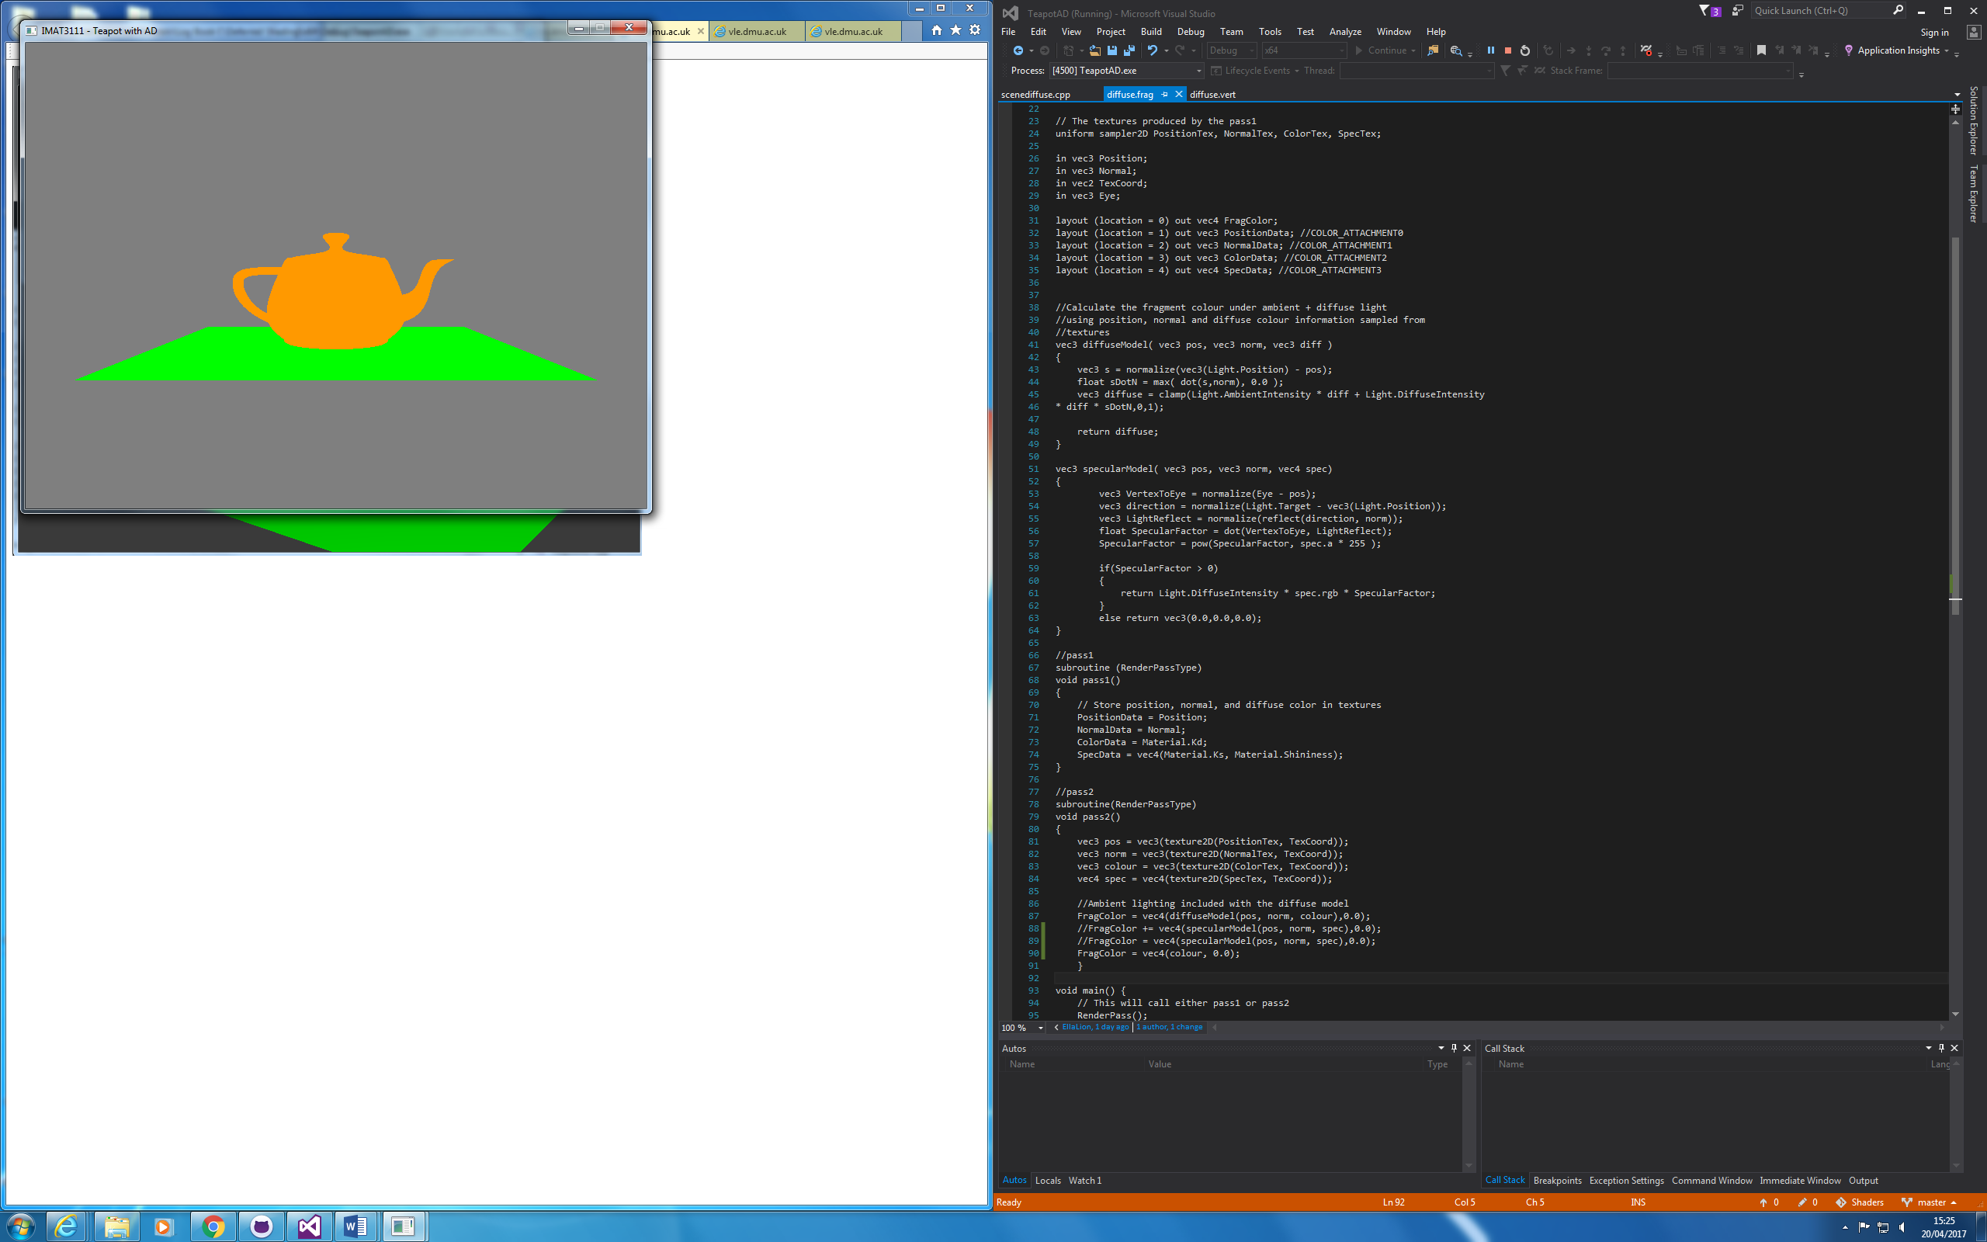

Ambient and Diffuse;

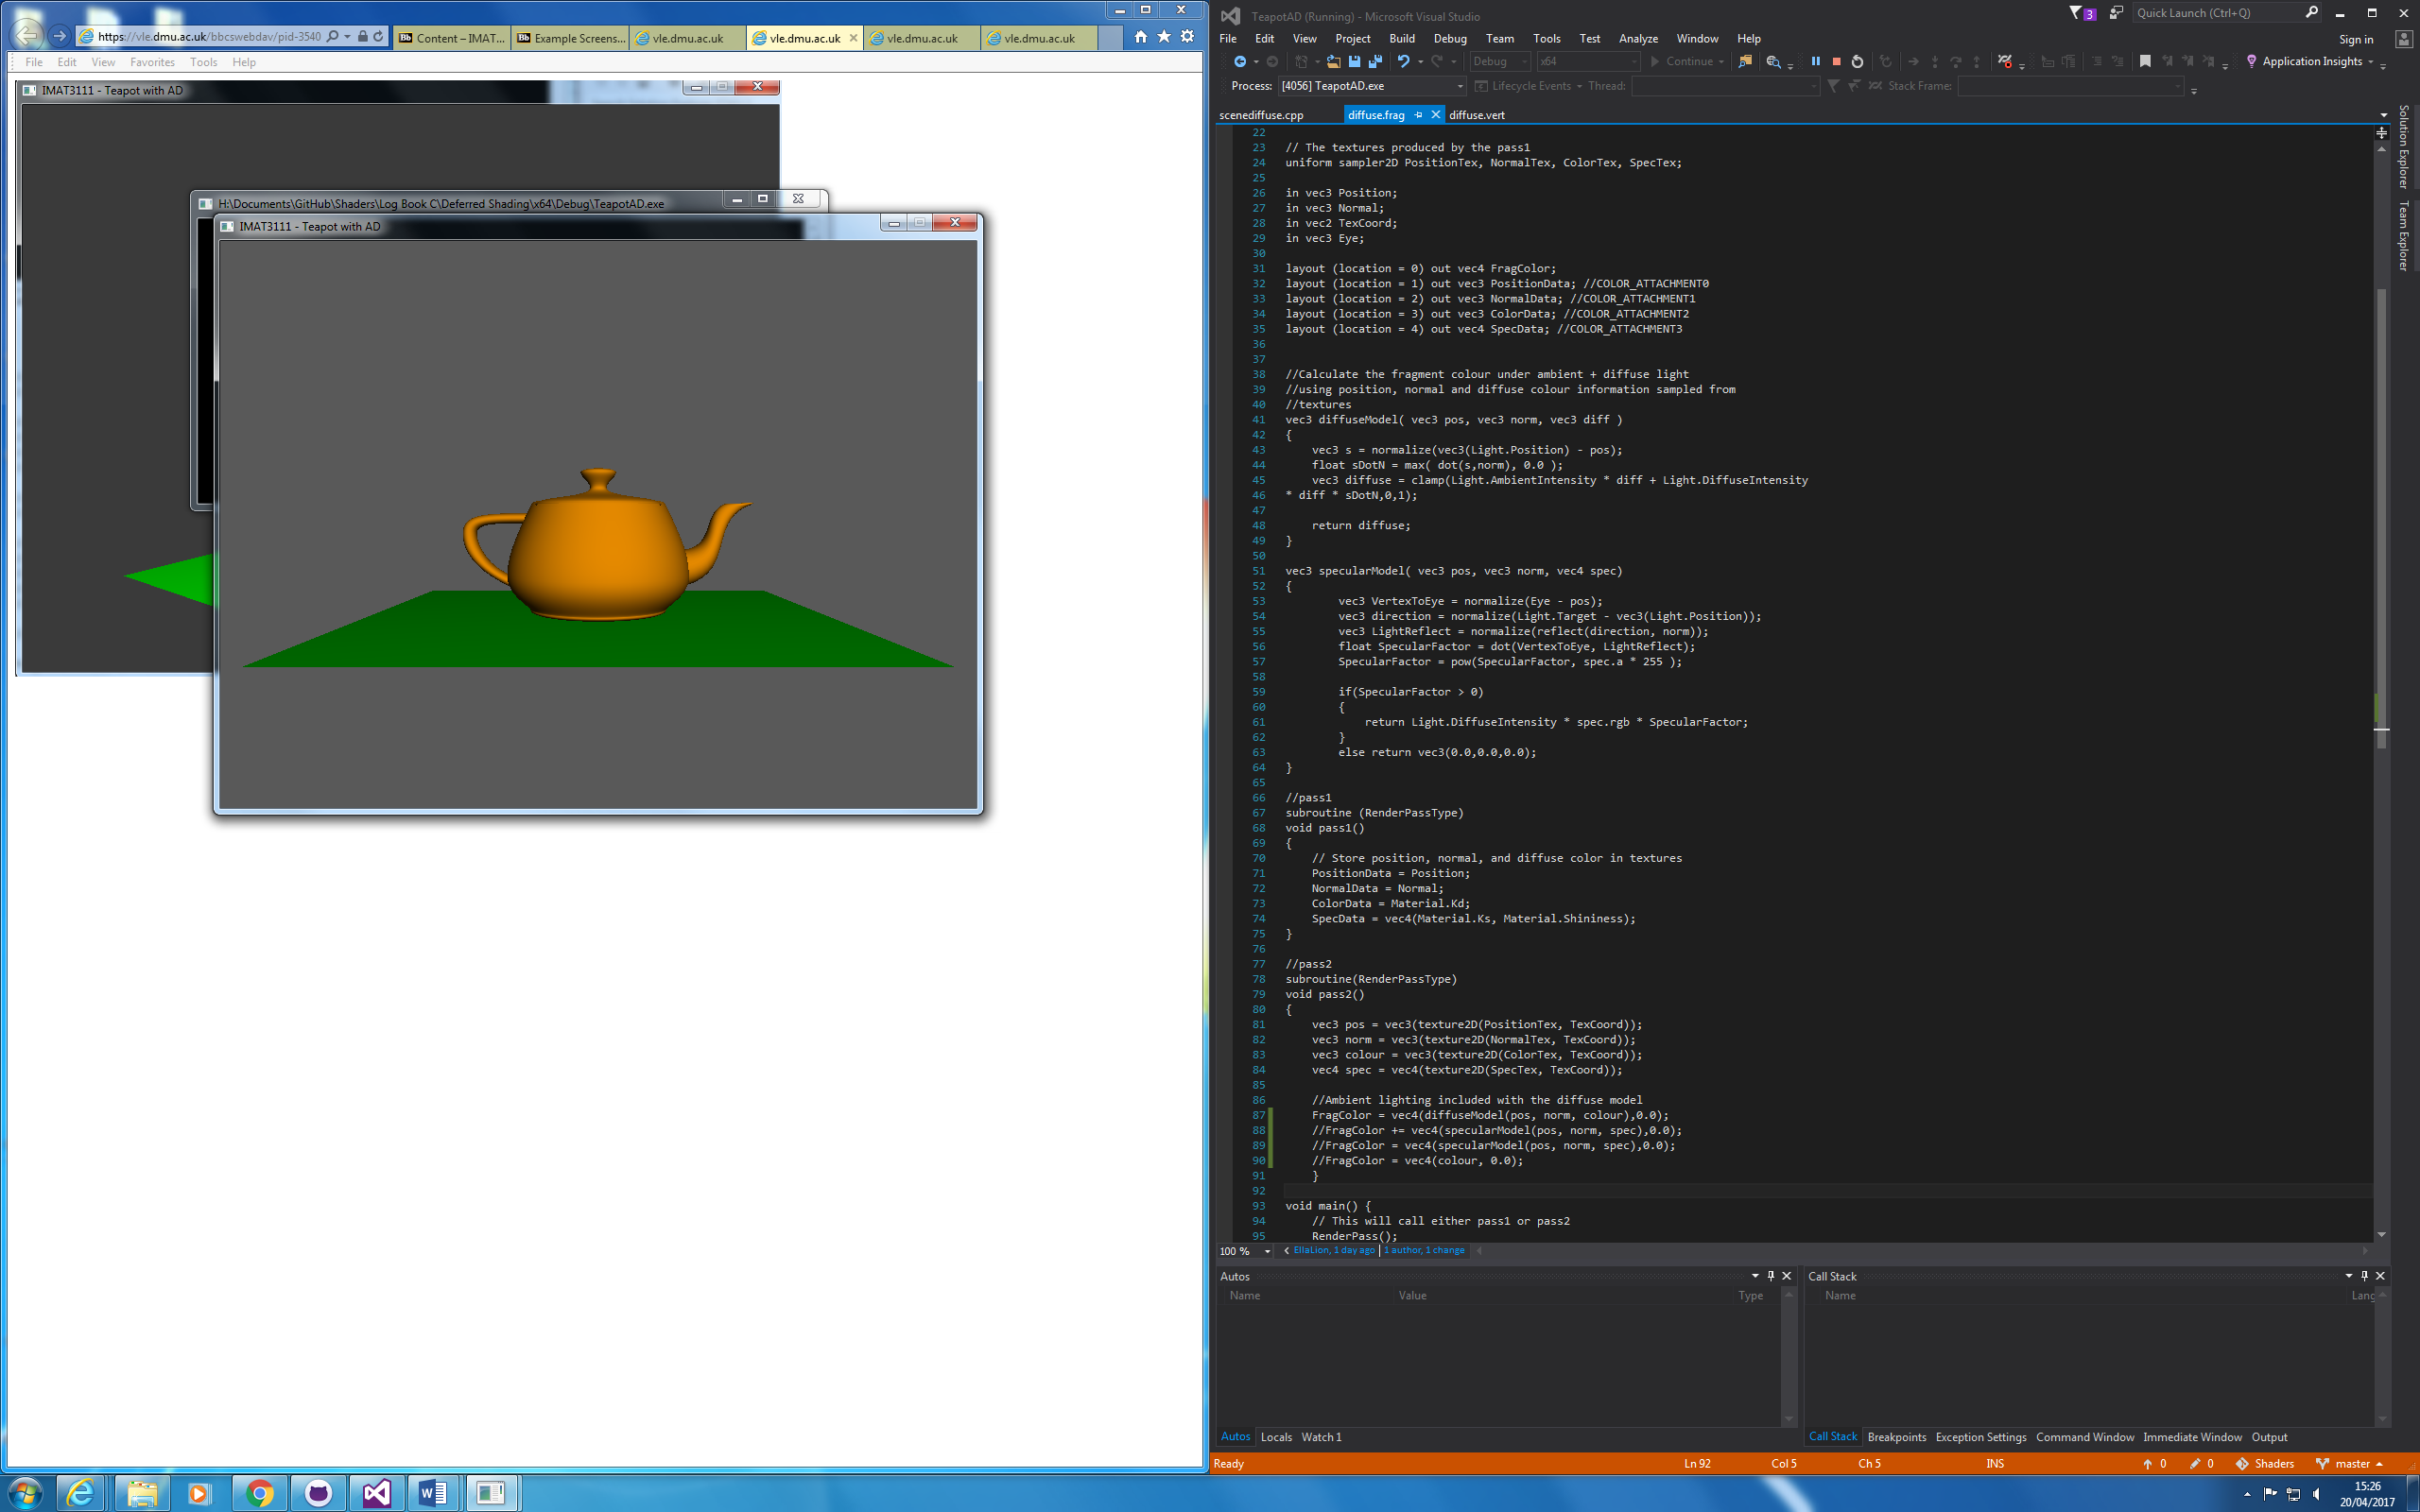

Specular Only;

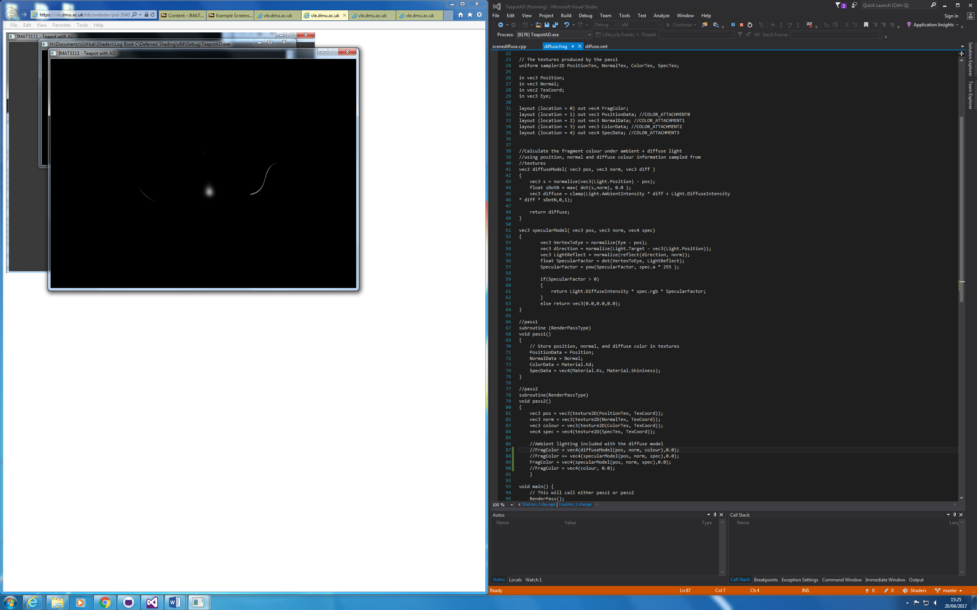

Phong Shading;

